PENETRATION TESTING REPORT
FOOTPRINTING & NETWORK SCANNING PHASES
W2-PM-FINAL | CYBERSECURITY | NETWORKWALKS

Pentester Name  (Cybersecurity Professional) | Faisal Zaman
Program/Batch | B084M-Networkwalks
Date | 10 November 2026
Modules completed | W2-PM1 (Multiple Kali Tools)  W2-PM5 (Zenmap Scanning)
Client/Target | 1. Networkwalks (secured written permission already)  2. My own local LAN Network
Permission secured from client? | Yes
Phases covered | Phase 1: Reconnaissance & Footprinting  Phase 2: Scanning & Network Discovery  Phase 3-5: In Progress

1. Liability Disclaimer (Legal and Ethical Use)
All activities were performed on personally owned or explicitly authorized systems. This material is intended solely for educational and research purposes. Unauthorized use is strictly prohibited. The instructor, authors, and Networkwalks are not responsible for any misuse. Always obtain proper authorization and comply with applicable laws and ethical cybersecurity practices.

2. Introduction
This report documents two key activities performed during Week 2 of my Networkwalks internship: domain footprinting of networkwalks.com using Kali Linux tools (W2-PM1) and scanning my own local network using Zenmap (W2-PM5).
These activities cover two important stages of cybersecurity assessment: gathering publicly available information about a target domain and identifying live hosts within a network.
All footprinting commands were executed in Kali Linux, while network scanning was performed using Zenmap on a Windows PC. Each activity includes the commands used, observed results, supporting screenshots, and a brief explanation of its relevance to cybersecurity and an attacker's perspective.

3. Tools Used
The table below lists each tool used in this report and its purpose.
Tool | Purpose
Kali Linux & Windows | Operating systems used for reconnaissance activities
WHOIS | Find domain registration details (owner, dates, name servers).
whatweb | Fingerprint web technologies (server, CMS, plugins, IP).
nslookup | Resolve the domain name to its IP address using DNS.
curl -I | Read the HTTP response headers of the website.
wafw00f | Detect whether a Web Application Firewall protects the site.
dnsrecon | Enumerate all DNS records (NS, MX, SPF, TXT, SRV).
Zenmap (Nmap GUI) | Scan the local subnet to find live hosts, IPs and MAC addresses.
Windows CMD | Local IP and MAC address identification

4. Activities Performed

4.1 Footprinting & Reconnaissance
I conducted reconnaissance on the networkwalks.com domain using six Kali Linux tools: WHOIS, WhatWeb, Nslookup, Curl, Wafw00f, and DNSRecon. Each tool was used to gather specific information about the target domain and its web infrastructure.
First, WHOIS was used to retrieve publicly available domain registration details, including registration information and name servers.
Next, WhatWeb was used to identify the technologies powering the website. The scan detected WordPress 7.0.4 and WP Download Manager 3.3.58, along with other technology-related details.
Using Nslookup, I resolved the domain name to its associated IP address: 192.232.216.135.
I then used Curl with the -I option to examine HTTP response headers. The results provided information about the web server and revealed the WordPress REST API endpoint (/wp-json/).
After that, Wafw00f was used to identify the presence of a Web Application Firewall (WAF). The results indicated ModSecurity (SpiderLabs).
Finally, DNSRecon was used to enumerate DNS records and gather information about name servers, mail servers, SPF/TXT records, service records, and DNS-related infrastructure.
Together, these tools provided an overview of the domain's publicly exposed information, web technologies, DNS configuration, and security infrastructure.

4.2 Network Scanning with Zenmap

4. Local Network Scanning Using Zenmap
For the second activity, I used Zenmap to perform network discovery on my local network. The objective was to identify my local IP address and subnet, discover live hosts, identify their IP and MAC addresses, and generate a network topology.
I first used the Windows ipconfig command to identify my local IP address (10.79.239.82) and subnet (10.79.239.0/24). I then configured my Kali Linux VM to use the same subnet through VirtualBox Bridged Adapter mode. Kali received the IP address 10.79.239.204.
Next, I entered 10.79.239.0/24 as the target in Zenmap and selected Ping Scan to discover active hosts.
The scan covered 256 IP addresses and identified three live hosts:
- 10.79.239.68 – Default Gateway
- 10.79.239.82 – Windows Host
- 10.79.239.204 – Kali Linux VM
The scan confirmed that all three devices were reachable on the local network. I also collected available MAC address information using Windows ipconfig /all, Kali's ip a command, and ARP information.
Finally, I used Zenmap's Topology tab to visualize the discovered network structure, enabled the legend, and saved the topology in PDF format as required by the practical task.

5. Risk Analysis / Impact

5. Potential Security Risks and Observations
Based on the information gathered during the domain footprinting and local network scanning activities, I identified the following security observations and potential risks. These findings highlight information that could be useful during further security assessments and may require additional investigation.
# | Risk / Finding | Evidence / Observation | Potential Impact | Risk Level
1 | Web technology information exposed | WhatWeb identified WordPress 7.0.4 and WP Download Manager 3.3.58. | Attackers may use software and version information to identify components requiring further security review. | ● Medium
2 | Server IP address identifiable | Nslookup resolved the domain to 192.232.216.135. | Provides information about the web server's network location and infrastructure. | ● Low
3 | HTTP technical information exposed | Curl retrieved HTTP response headers and revealed the /wp-json/ endpoint | May assist technology fingerprinting and further web application enumeration. | ● Low
4 | WAF technology identifiable | Wafw00f identified ModSecurity (SpiderLabs) | Reveals information about the website's security architecture that may help attackers understand its defensive technologies | ● Low
5 | DNS infrastructure information exposed | DNSRecon identified DNS, mail, SPF/TXT and service-related records. | Public DNS information may help build a broader profile of the organization's infrastructure. | ● Medium
6 | Multiple live hosts visible on local network | Zenmap identified three live hosts: 10.79.239.68, 10.79.239.82 and 10.79.239.204. | Unknown or unauthorized devices, if present, could increase the network's attack surface. | ● Medium

Risk level key: ● Critical ● Medium ● Low
The risks above are observations from the footprinting and scanning exercises, not confirmed vulnerabilities.
The practical exercises primarily involved information gathering and host discovery. No exploitation or vulnerability validation was performed as part of these two modules.
Therefore, the presence of information such as a software version, IP address or DNS record does not by itself mean that the system is vulnerable. Further authorized security testing would be required to confirm any actual vulnerability.

6. Recommendations
Based on the observations from the domain footprinting and network scanning activities, the following security improvements are recommended:
- Review Publicly Exposed Technology Information
Regularly review publicly accessible information about web technologies, CMS platforms, and installed plugins.
- Keep Software Updated
Update CMS platforms, plugins, and other web components regularly. Check for known vulnerabilities and applicable security advisories.
- Review HTTP Response Headers
Examine HTTP headers and minimize unnecessary disclosure of server and application details.
- Review DNS Records Regularly
Periodically audit DNS records to ensure that only necessary services and information are publicly exposed.
- Properly Configure and Monitor the WAF
Keep ModSecurity enabled, apply appropriate security rules, and regularly monitor its logs for suspicious activity.
- Perform Regular Network Discovery
Conduct periodic scans of authorized internal networks to identify active devices and monitor network changes.
- Investigate Unknown Devices
Verify unexpected devices and investigate any unauthorized connections to the network.
- Maintain Updated Network Documentation
Keep network topology diagrams, IP addresses, and device inventories accurate and up to date.
- Conduct Authorized Security Testing
Perform reconnaissance, vulnerability assessments, and network scanning only on systems for which proper authorization has been obtained.

7. Conclusion
During Week 2 of my Cybersecurity & Ethical Hacking internship, I completed practical exercises involving domain footprinting, reconnaissance, and local network scanning.
For the domain footprinting activity, I used six Kali Linux tools to gather information about the target domain. I learned how WHOIS retrieves domain registration details, WhatWeb identifies web technologies, Nslookup resolves domain names, Curl examines HTTP response headers, Wafw00f detects Web Application Firewalls, and DNSRecon gathers DNS-related information.
For the network scanning activity, I used Zenmap to identify my local network configuration and discover active hosts. I also examined available IP and MAC address information and generated a network topology to visualize the discovered devices.
These exercises demonstrated that information gathering is a fundamental stage of cybersecurity assessment. Before attempting any exploitation, security professionals can gain valuable insights into a target environment by analyzing publicly available information and network responses.
I also learned the importance of accurate technical documentation. A professional cybersecurity report should clearly describe the activities performed, the observations made, their potential security implications, and the recommended actions to reduce associated risks.
Finally, I reinforced the importance of conducting reconnaissance and network scanning strictly within an authorized scope. All activities documented in this report were performed as part of the assigned educational exercises during my internship.

8. Evidences Collected

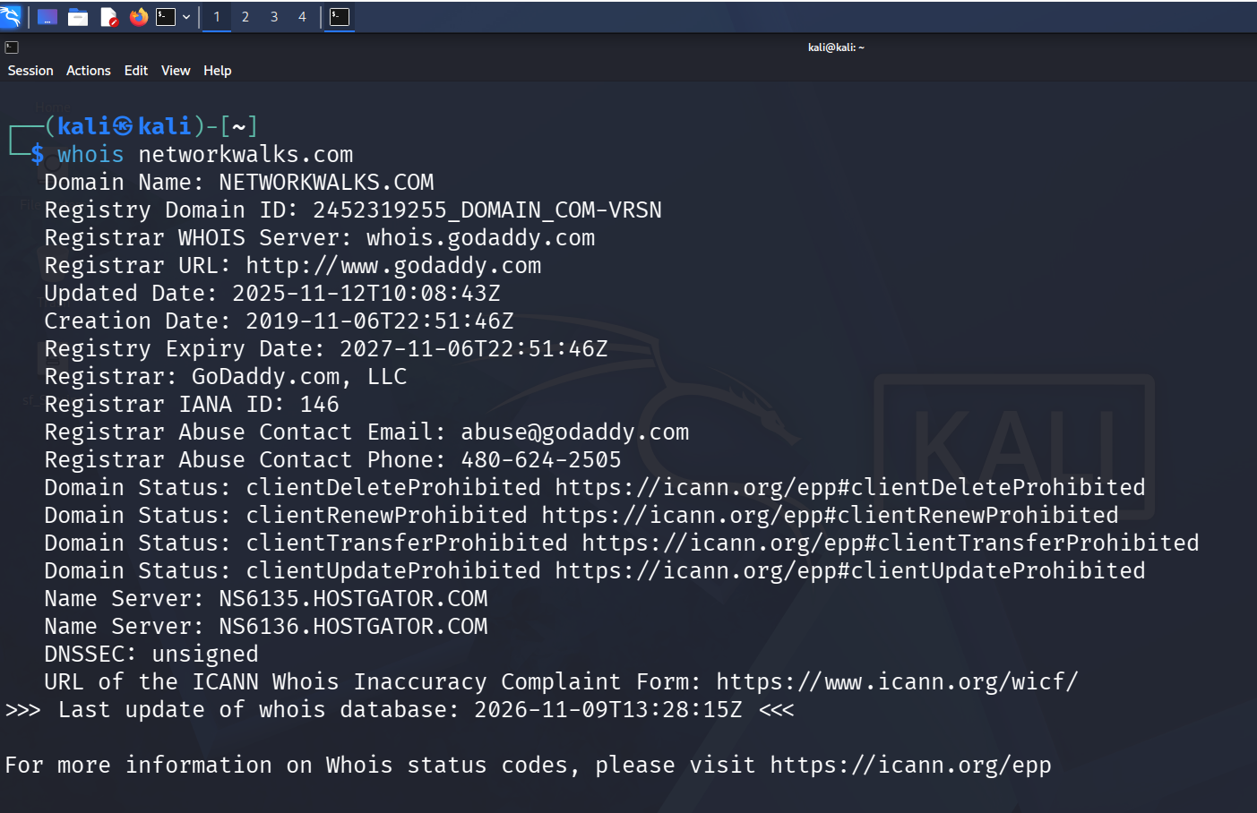

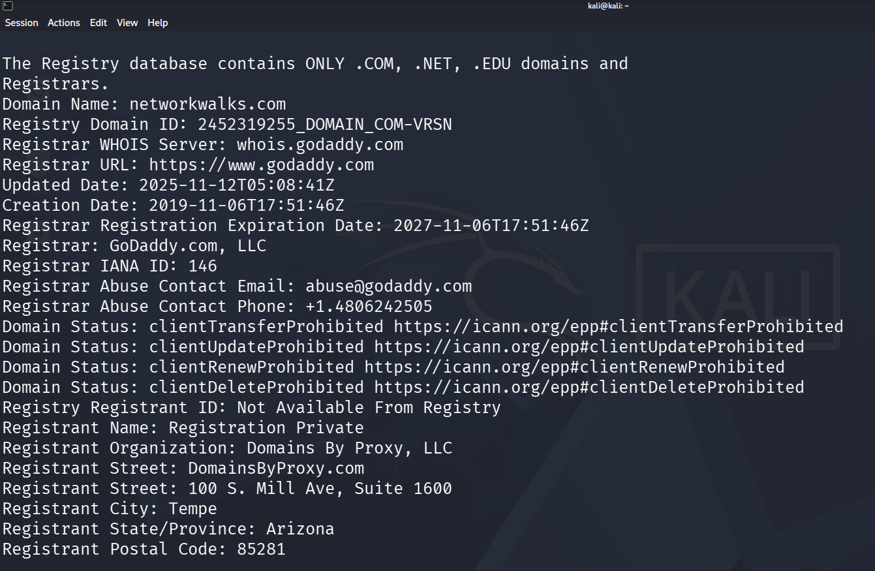

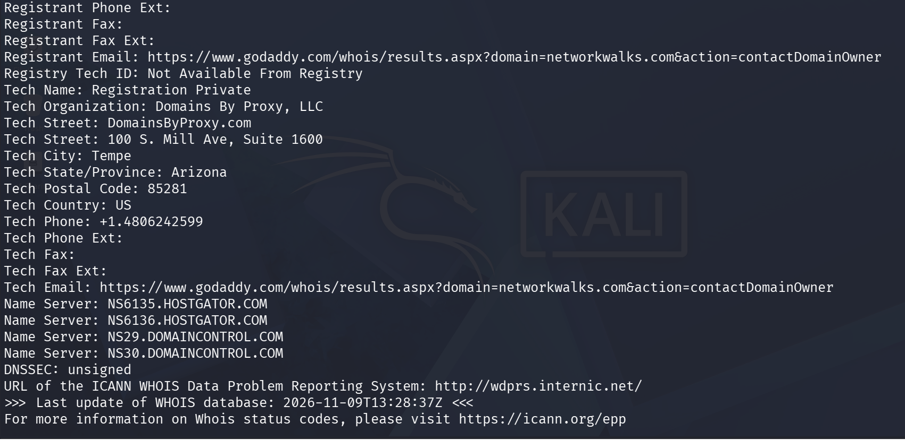

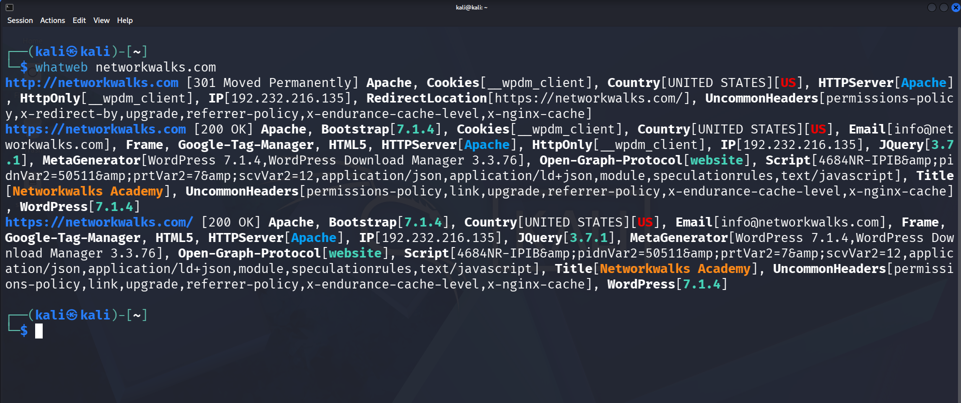

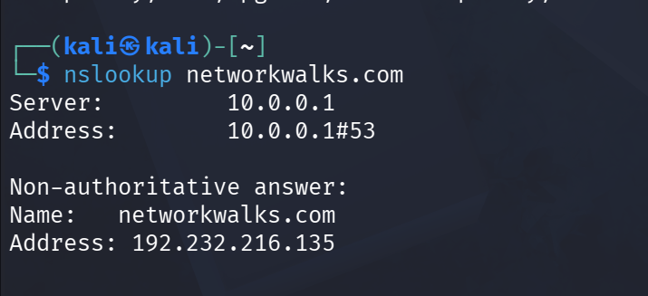

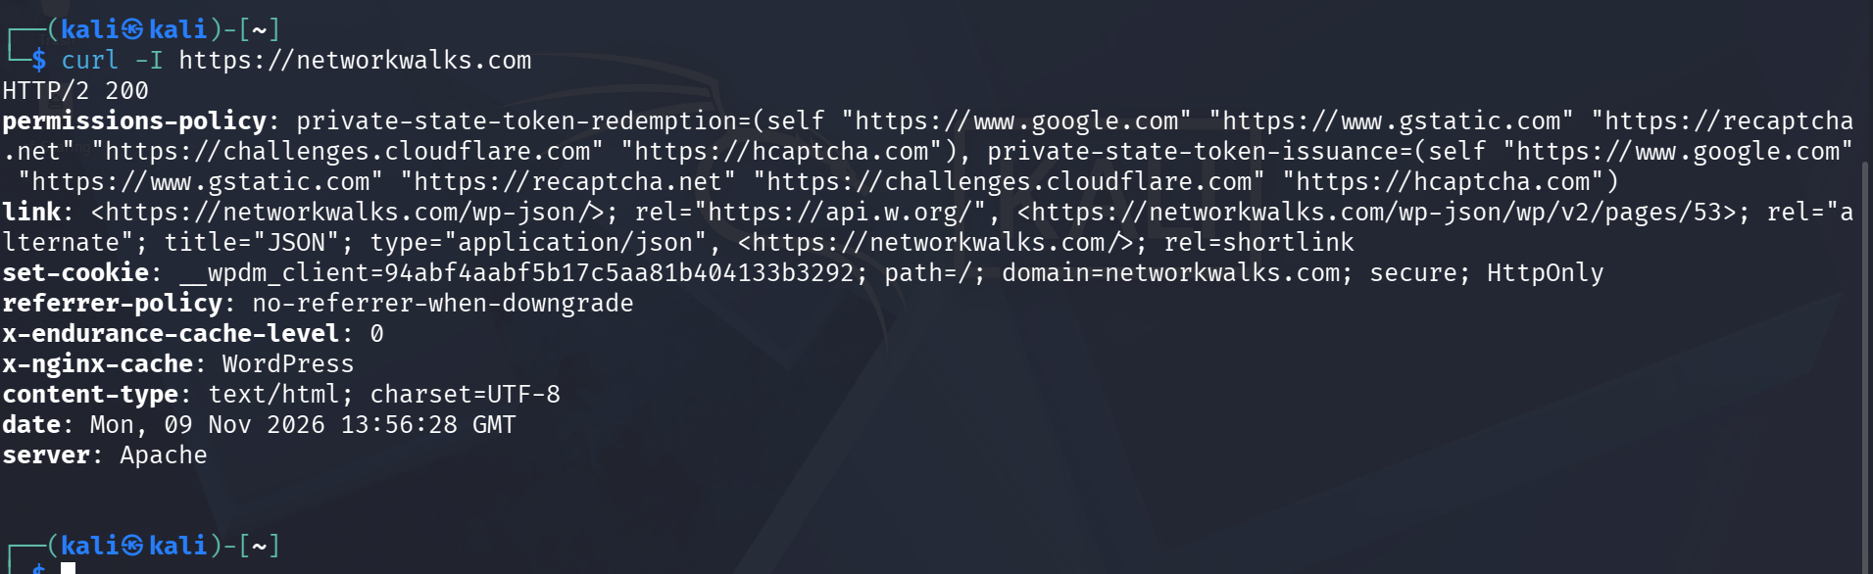

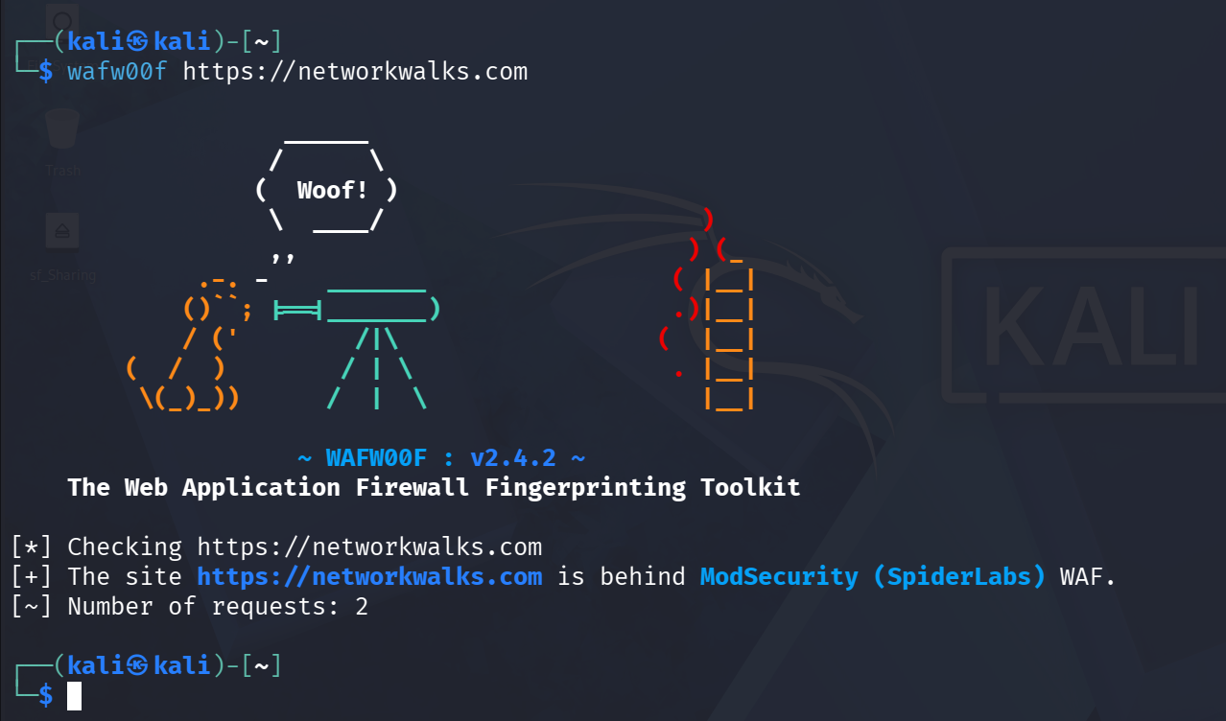

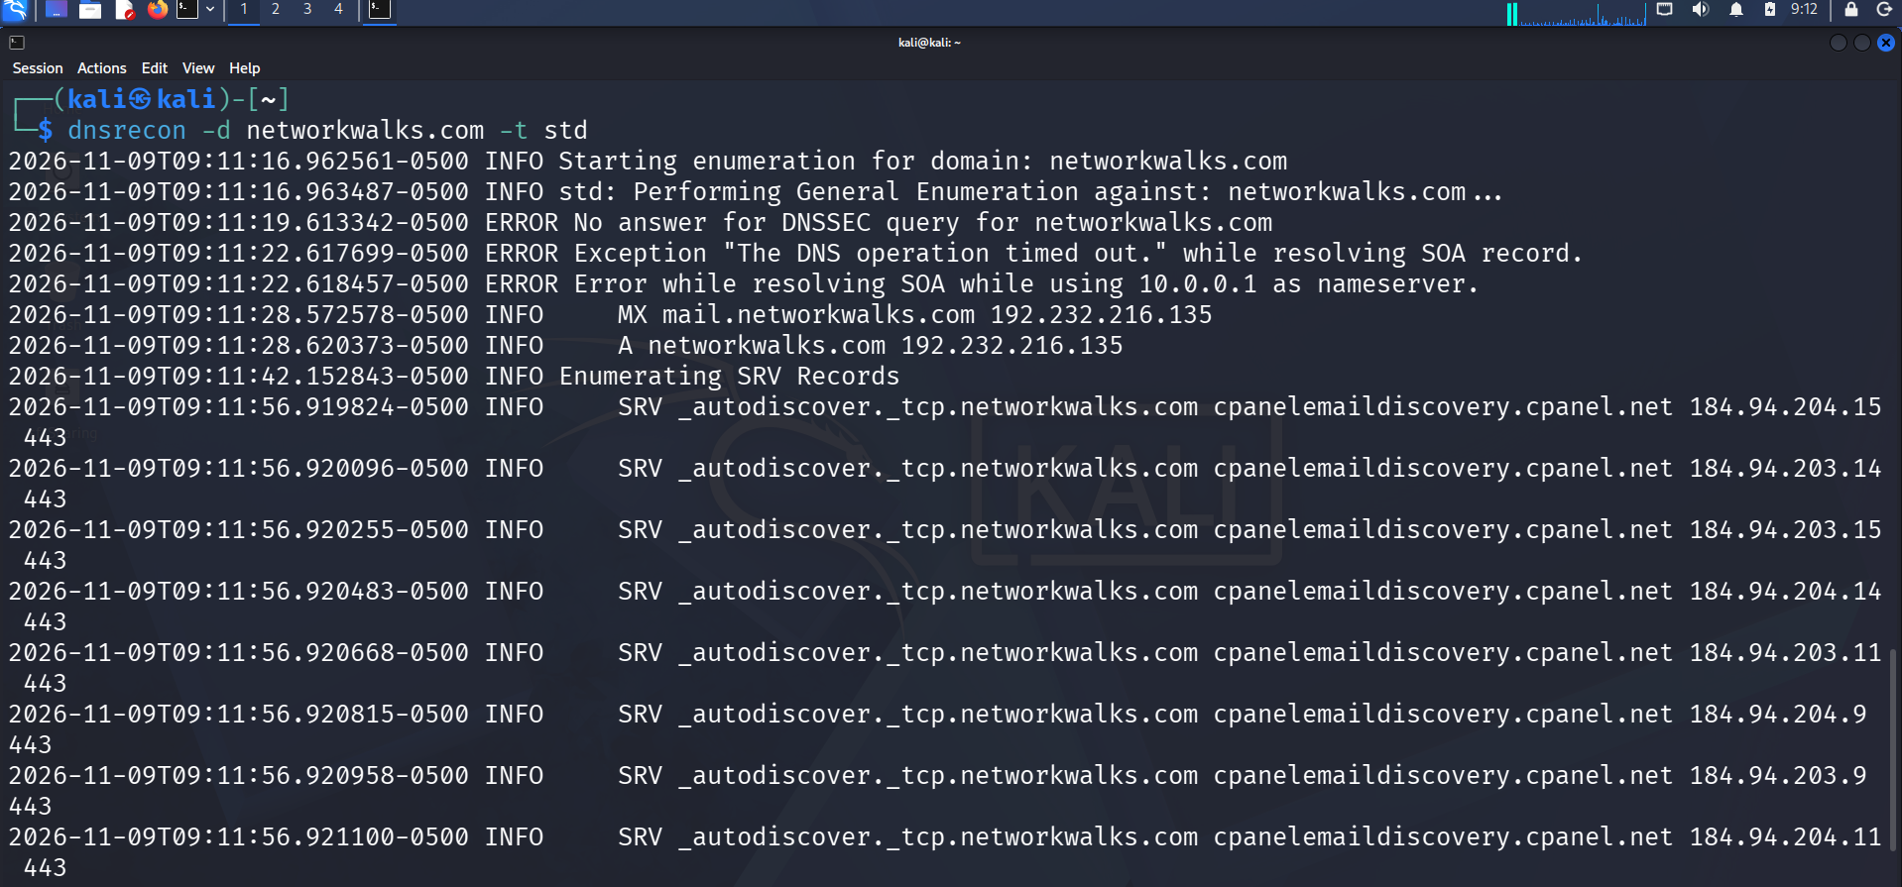

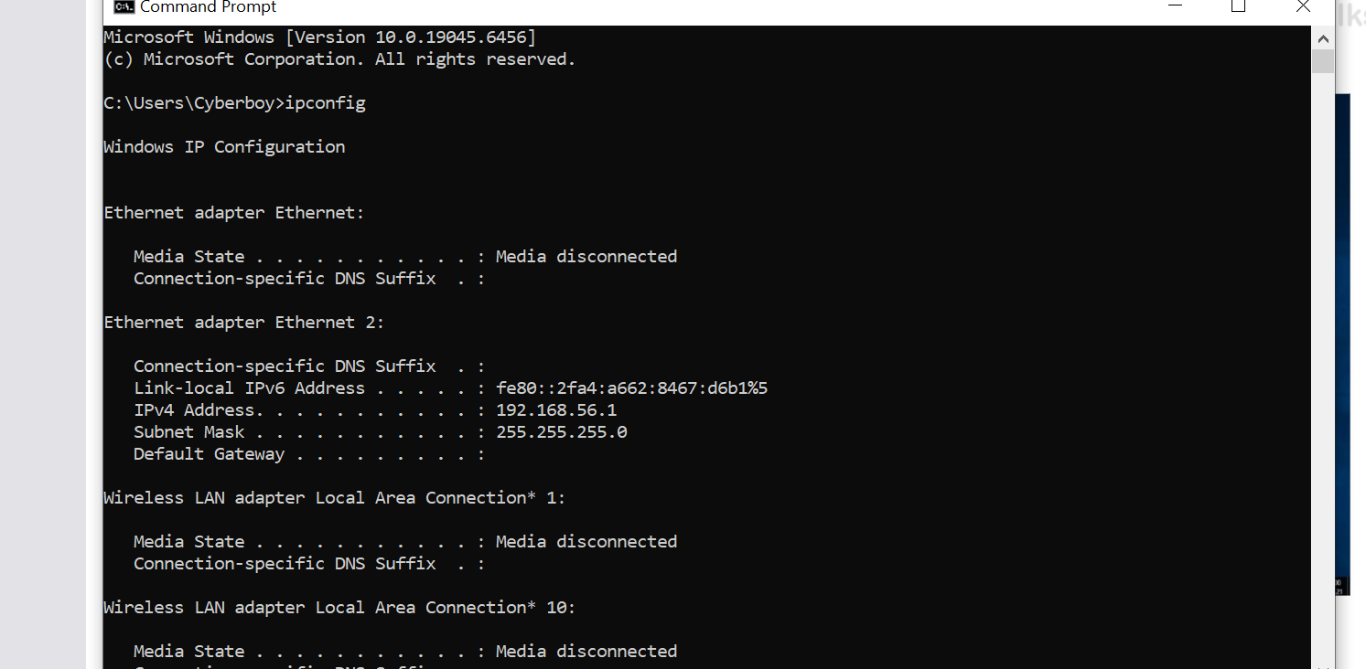

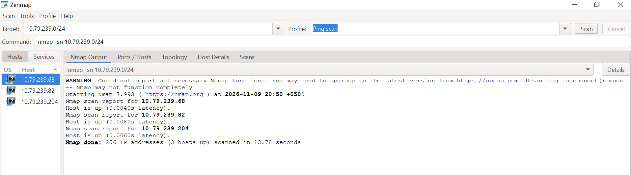

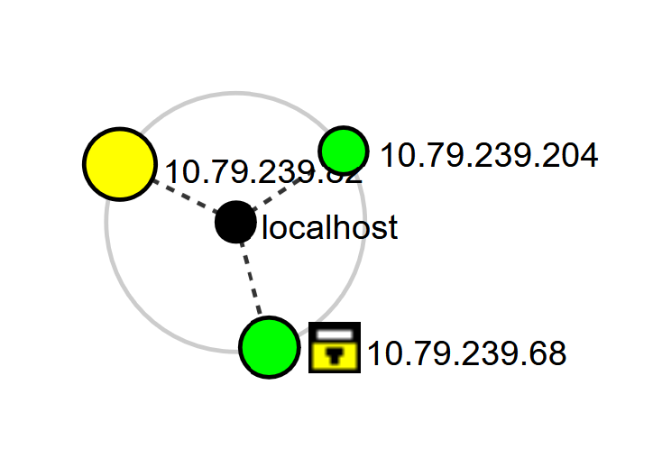

-End-

👤 Author
Faisal Zaman
Cybersecurity Professional B084
LinkedIn: https://www.linkedin.com/in/faisal-zaman-9a43b23a6/

📌 Project Information
Program Name: Cybersecurity program at Networkwalks | Week: 02 | Repository: GitHub: https://github.com/knownstranger051

